**Practical 2 : a) Write a shell script with basic commands like echo and read**

**b) Write a shell script to display addition of given two numbers**

**a)**

echo "enter you name "

read name

echo "Hello $name welcome to shell script"

Output :

enter you name

nakul dhrangadhariya

Hello nakul dhrangadhariya welcome to shell script

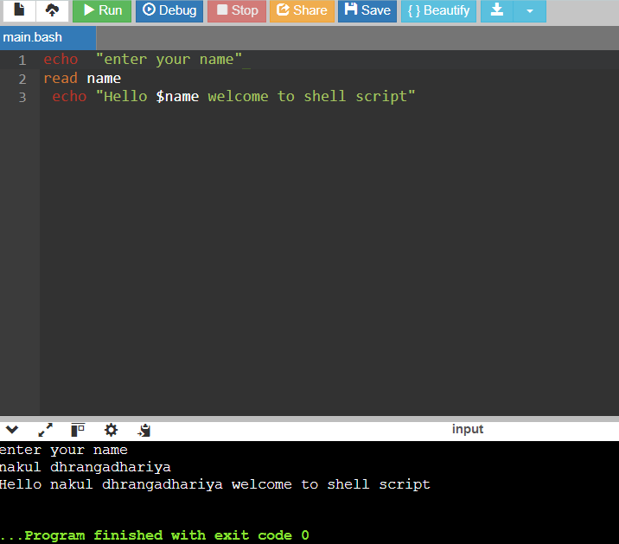

**Figure 2.1 : printing in bash**

b)

echo "my name is nakul dhrangadhariya"

echo "my enrollment number is 92410103118"

echo "my class is EC5-C"

echo "enter no1"

read no1

echo "enter no2"

read no2

sum=$((no1+no2))

echo "sum is $sum"

Output:

my class is EC5-C

enter no1

11

enter no2

12

sum is 23

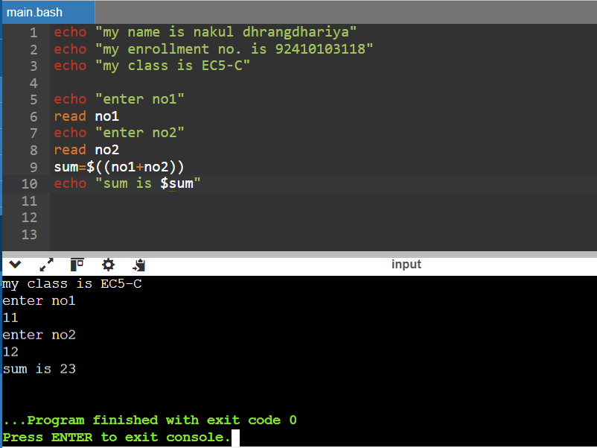

Figure 2.2 : adding two numbers